TO WHOM IT MAY CONCERN

I feel compelled to send a review/recommendation of my experience working with Kendall Martin of
Kendall Martin Media
Photo | Video | Social
Web | Instagram | LinkedIn
I have just received the images achieved by him during a 4 day project at my Bali property:
VILLA SUNGAI BALI
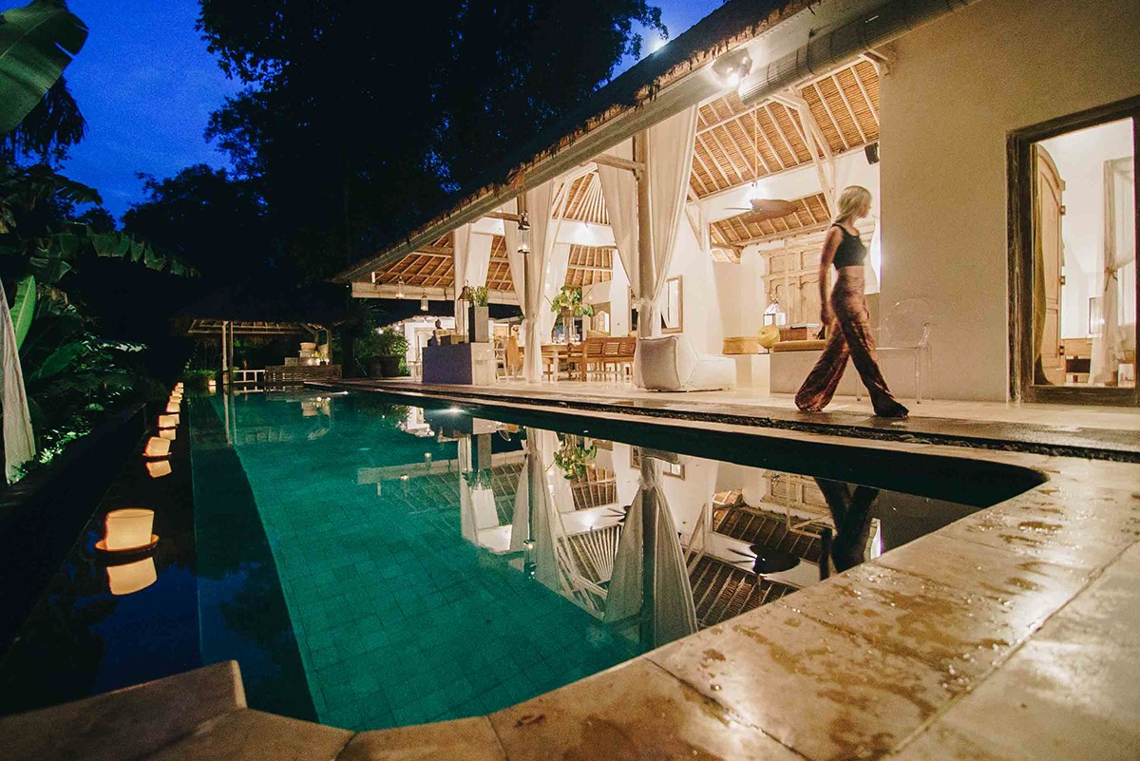
On the strength of these, and the professionalism of Kendall during our lead-up communications, and then in his processing everything quickly, that I am discussing his return to shoot another villa that is currently being enlarged and therefore in need of a re-shoot.
The turnaround of the initial images was less than a week, and he also undertook to send raw files to mrandmrssmith.com who were needing very high res images for a new VILLA site they wish to include us on.
As a photographer/influencer I cannot recommend him too highly to anyone in search of a collaboration for creating content of interiors/exteriors with detail/lifestyle content.
He is also highly sought for content + social media promotion
His photography page is outstanding. He has captured better imagery of Indonesia than I have ever seen before.

Kind regards
Pamela
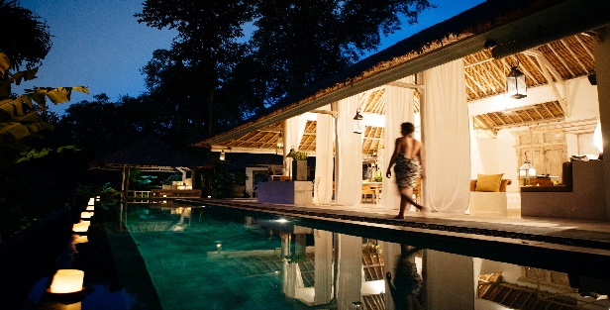
Pamela Hayes
+61(0) 410 324 535
info@bali-villasungai.com
www.bali-villasungai.com

Web / Blog / Instagram / Facebook / Twitter / Vimeo / Youtube
Get social with us before, during and after your stay by tagging us @villasungai #villasungai
3 x Winner of the Best Overseas Boutique Property, Villa or Lodge
[Luxury Travel Magazine]

